The entire wordings needs to be rephrased, and also the color coding we can apply the Adprime in this case
Dashboard UI, we can add this (rephrase this before adding )
Provides a comprehensive analysis of campaign performance, featuring temporal insights and inventory performance insights alongside week-by-week and device/app trends.
Presents key observations with actionable, data-driven recommendations to optimize future campaigns and better align with strategic goals.
Click on Generate Report, and it can show a pop-up where they cacn select the camp ids and click on generate report which will be split into 4 tabs
1 - Campaign Performance Report
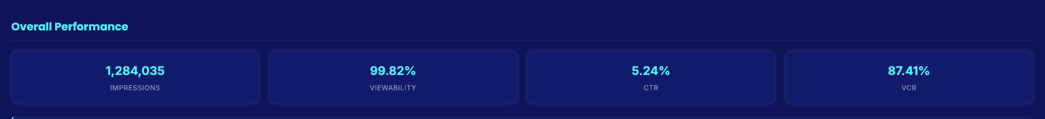

The campaign successfully exceeded its impression delivery goal by 0.15%, delivering 1,284,035 impressions against a target of 1,282,051. Performance metrics were exceptionally strong across all key indicators, with 99.82% viewability, 5.24% CTR, and 87.41% VCR, demonstrating both excellent ad placement quality and strong audience engagement.

Weekly Performance Trend
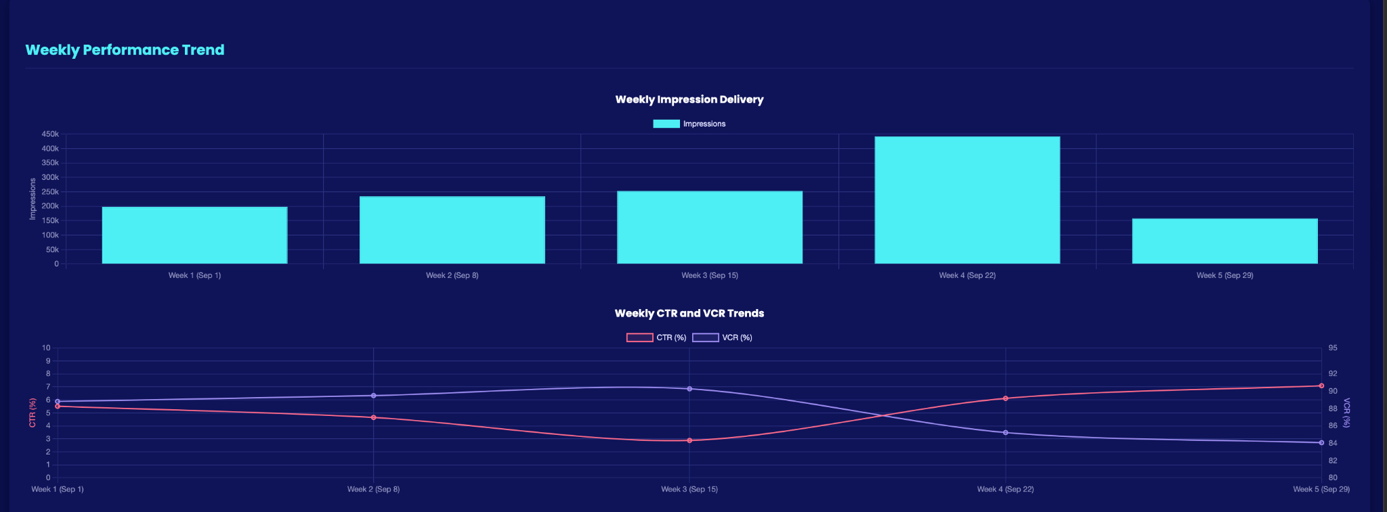
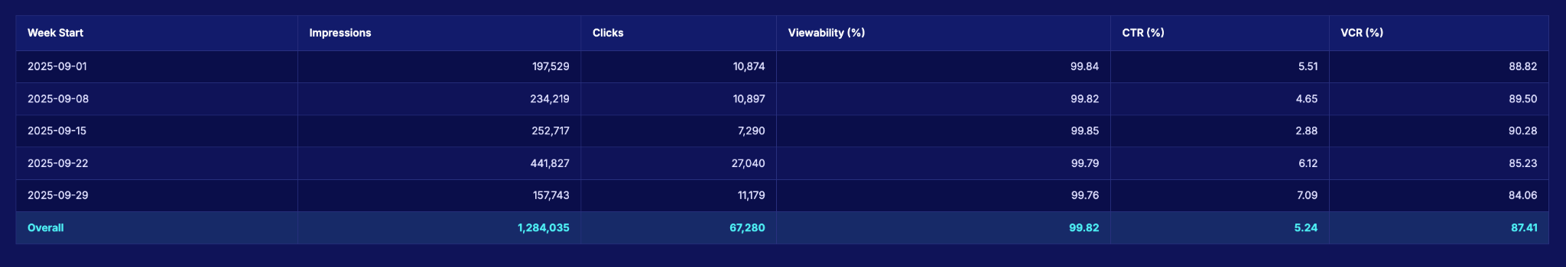

Impression Delivery: The campaign showed a steady increase in weekly impressions from Week 1 through Week 3, followed by a dramatic 74.8% spike in Week 4 (441,827 impressions), which accounted for 34.4% of the total campaign delivery. Week 5 shows a significant drop, likely representing only the final two days of the campaign.

Click-Through Rate (CTR): CTR displayed considerable fluctuation throughout the campaign. Starting strong at 5.51% in Week 1, it declined over the next two weeks, reaching a low point of 2.88% in Week 3. However, CTR rebounded dramatically in Week 4 (6.12%) and peaked in Week 5 (7.09%), ending 35.3% above the campaign average.

Viewability: Viewability remained exceptionally consistent throughout the campaign, with minimal fluctuation between 99.76% and 99.85%. This indicates consistently premium ad placements across all weeks of the campaign.

Video Completion Rate (VCR): VCR showed an interesting pattern, steadily increasing from Week 1 (88.82%) to Week 3 (90.28%), before declining in Weeks 4 and 5 to finish at 84.06%. This represents a 6.22 percentage point drop from the peak in Week 3 to the end of the campaign.
Key Insights & Recommendations
1 Impression Volume vs. Engagement Quality Trade-off
The significant spike in impressions during Week 4 (74.8% increase) coincided with a decline in VCR (5.05% decrease), suggesting a potential quality-quantity trade-off. This could indicate expansion into new inventory sources or audience segments with different viewing behaviors.

2 CTR Recovery Pattern
The dramatic recovery in CTR from Week 3 (2.88%) to Week 4 (6.12%) and Week 5 (7.09%) suggests possible creative optimization or targeting refinements mid-campaign. The Week 3 CTR anomaly (45% below campaign average) may have triggered adjustments that led to improved performance.

3 Inverse Relationship Between CTR and VCR
As CTR increased in Weeks 4-5, VCR decreased, potentially indicating that more engaging or clickable ad placements may have come at the expense of complete video views. This could reflect a shift in inventory mix or audience targeting strategy.

4 Delivery Pacing Strategy
The campaign appears to have employed a back-loaded delivery strategy, with 46.7% of all impressions delivered in the final 9 days. This approach successfully met the overall impression goal but created significant weekly delivery variations.

5 Consistent Viewability Despite Fluctuations
The remarkably stable viewability metrics (99.76%-99.85%) across all weeks, despite significant fluctuations in other metrics, demonstrates that premium placement quality was maintained even as delivery volume and engagement metrics varied.

2nd Tab
Platform and Device Performance
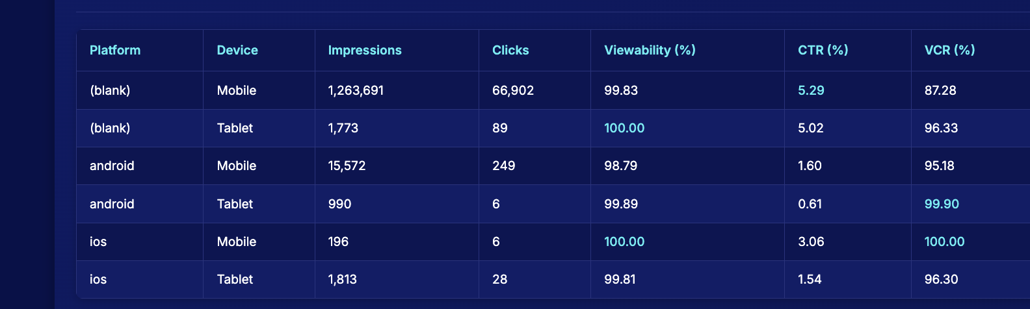

The campaign performance shows significant variations across platforms and devices:

Platform Distribution: The "(blank)" platform dominates with 98.4% of all impressions (1,265,464 out of 1,284,035 total impressions), primarily on mobile devices. This suggests either a data categorization issue or that the campaign is heavily concentrated on a single platform.
CTR Performance: The "(blank)" platform significantly outperforms identified platforms with CTRs of 5.29% (mobile) and 5.02% (tablet), compared to much lower rates on Android (1.60% mobile, 0.61% tablet) and iOS (3.06% mobile, 1.54% tablet). This represents a performance gap of over 230% between the best and worst performing device-platform combinations.
VCR Patterns: Interestingly, the pattern reverses for video completion rates. Android and iOS devices show superior VCR performance (95.18%-100%) compared to the dominant "(blank)" platform on mobile (87.28%). This suggests that while users on the "(blank)" platform are more likely to click, they're less likely to complete video views.
Device Trends: Across all platforms, mobile devices generally drive higher CTR than tablets on the same platform, but tablets tend to have higher VCR. This indicates different user engagement patterns based on device type.
Viewability Excellence: Viewability remains consistently high (>98.7%) across all platforms and devices, indicating excellent ad placement and delivery throughout the campaign.

Temporal Performance Analysis
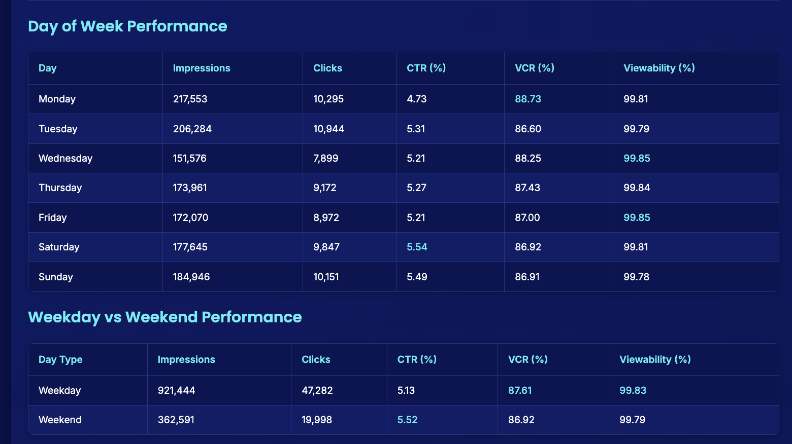

The temporal analysis reveals several important patterns:

Weekend Engagement Advantage: Weekend days show significantly higher engagement rates, with Saturday (5.54%) and Sunday (5.49%) having the highest CTR of any day. Overall, weekend CTR (5.52%) is 7.6% higher than weekday CTR (5.13%), suggesting users are more receptive to advertising during leisure time.
Weekday Completion Strength: Despite lower click rates, weekdays demonstrate stronger video completion rates (87.61% vs 86.92% on weekends). Monday in particular has the highest VCR (88.73%) despite having the lowest CTR (4.73%), indicating that weekday viewers who engage with ads are more likely to watch them to completion.
Day-Specific Patterns:
Monday shows an interesting pattern with the highest impression volume (217,553) but lowest CTR (4.73%), suggesting high exposure but lower engagement efficiency.
Wednesday has the lowest impression volume (151,576, 26.3% below daily average) but maintains above-average CTR and VCR, potentially indicating an efficient day for targeted delivery.
Saturday combines high CTR with moderate impression volume, making it potentially the most efficient day for the campaign.
Impression Distribution: Weekdays account for 71.8% of total impressions, with relatively consistent daily distribution except for the notable dip on Wednesday. This suggests either a delivery strategy focused on weekdays or natural user behavior patterns favoring weekday activity.

Key Campaign Insights
1. Platform Concentration and Performance Divide: The campaign is overwhelmingly delivered on the "(blank)" platform (98.4% of impressions), which shows a distinct performance pattern: high CTR (5.29% on mobile) but lower VCR (87.28%) compared to identified platforms. This suggests that while the campaign's reach and click engagement are primarily driven by this platform, there may be opportunities to leverage the superior video completion rates seen on Android (95.18%-99.90%) and iOS (96.30%-100%) for campaigns where full video views are prioritized.

2. Weekend Engagement Opportunity: Weekend days consistently outperform weekdays in terms of CTR (5.52% vs 5.13%), with Saturday showing the highest engagement rate (5.54%) of any day. This 7.6% performance lift on weekends represents a significant opportunity for campaigns focused on maximizing user interaction. However, for campaigns prioritizing video completion, weekdays offer slightly better performance with a VCR of 87.61% compared to 86.92% on weekends.

3. Device-Specific Engagement Patterns: Across all platforms, mobile devices generate higher CTR than tablets on the same platform, while tablets consistently deliver higher VCR. This pattern suggests that future campaigns could be optimized by device type based on primary KPIs – leveraging mobile for click-focused campaigns and tablets for video completion objectives.

4. Day-of-Week Optimization Potential: The significant variation in both impression volume and performance metrics across days of the week presents clear optimization opportunities. Monday shows the highest impression volume but lowest CTR (4.73%), while Wednesday has the lowest impressions but above-average performance metrics. This suggests that reallocating budget from lower-performing days to higher-performing ones could improve overall campaign efficiency.

Inventory Pulse - 3rd Tab
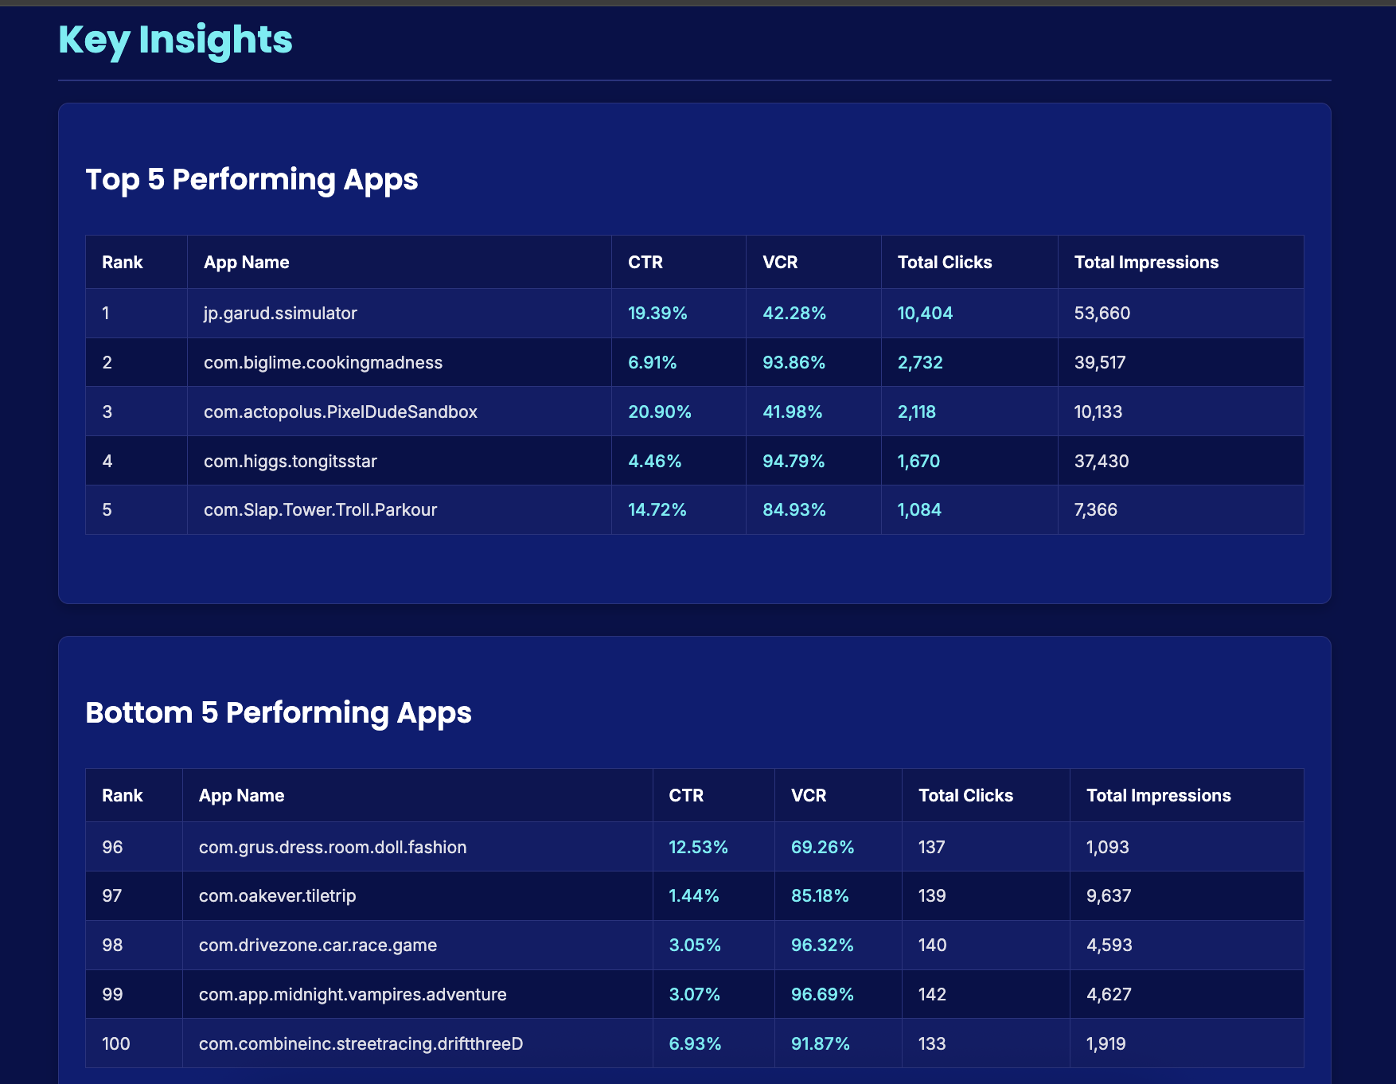
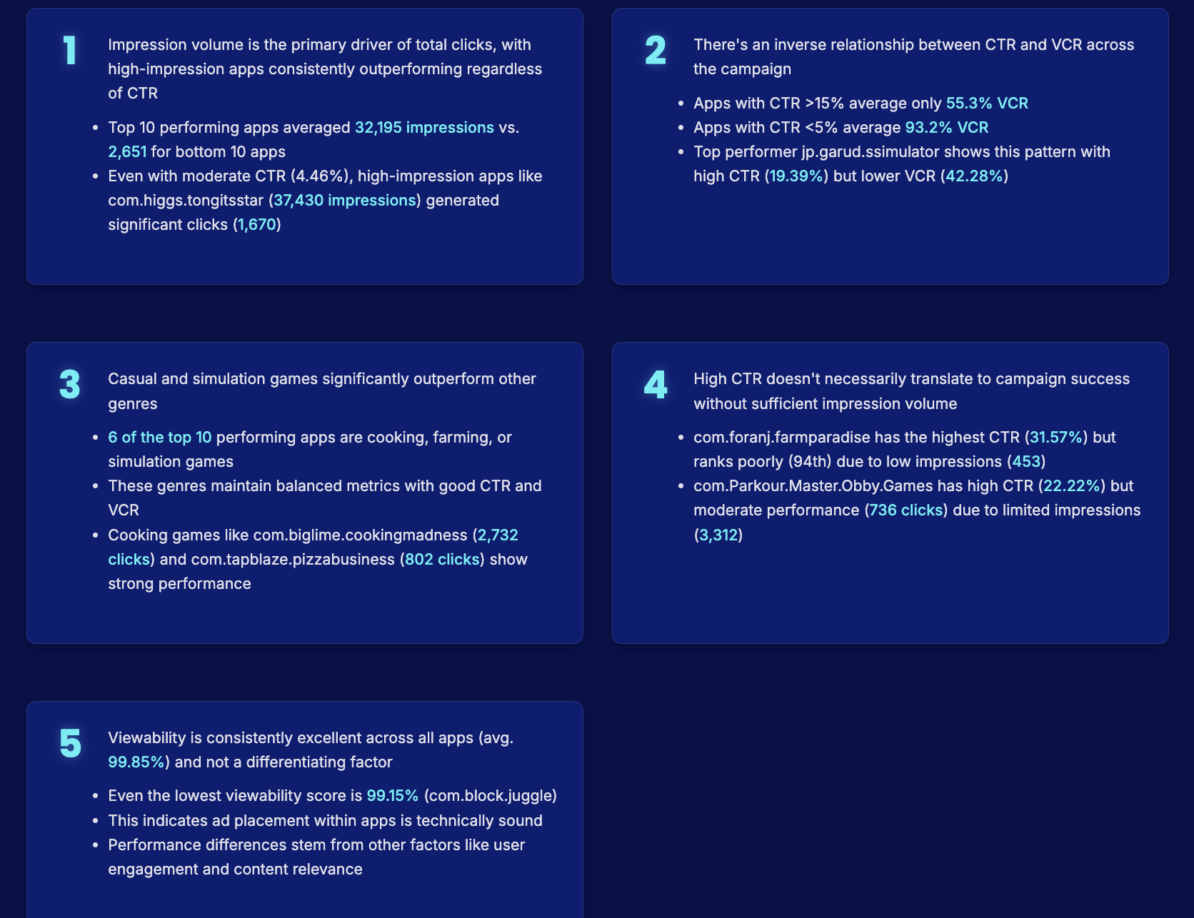
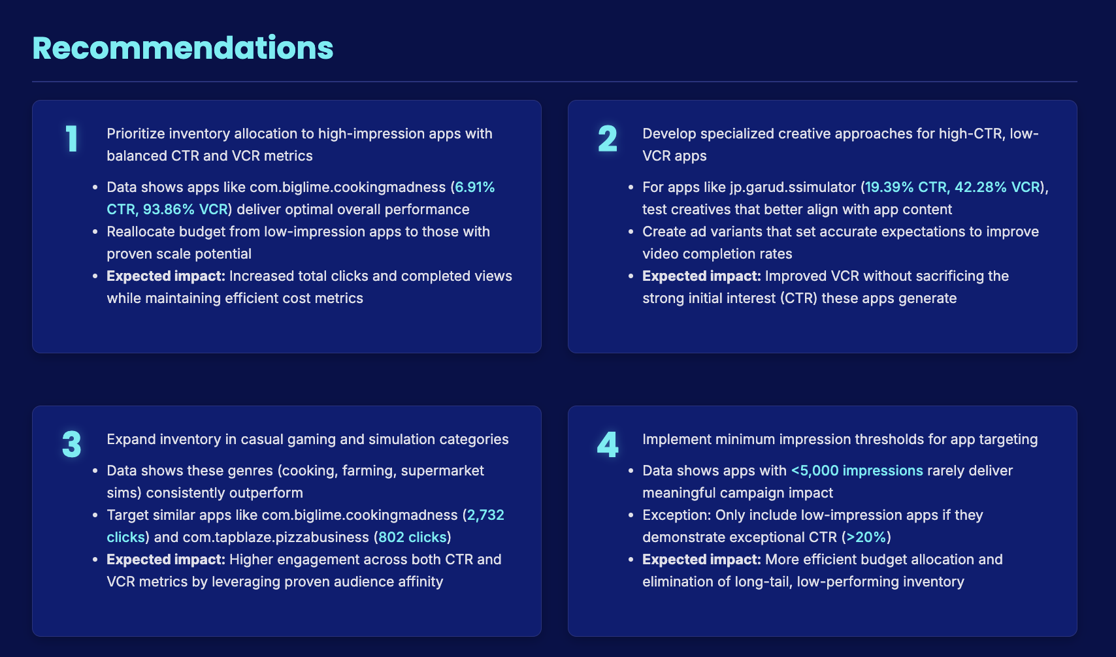

Key Observations and Insights
